(\*) Create trigger status upgrade

Trigger change status where we update end or start time in table transaction.

Approved: if start time is before 14 hours from end time Declined: if start time is after 14 hours from end time Pending: if start and end time are within 14 hours

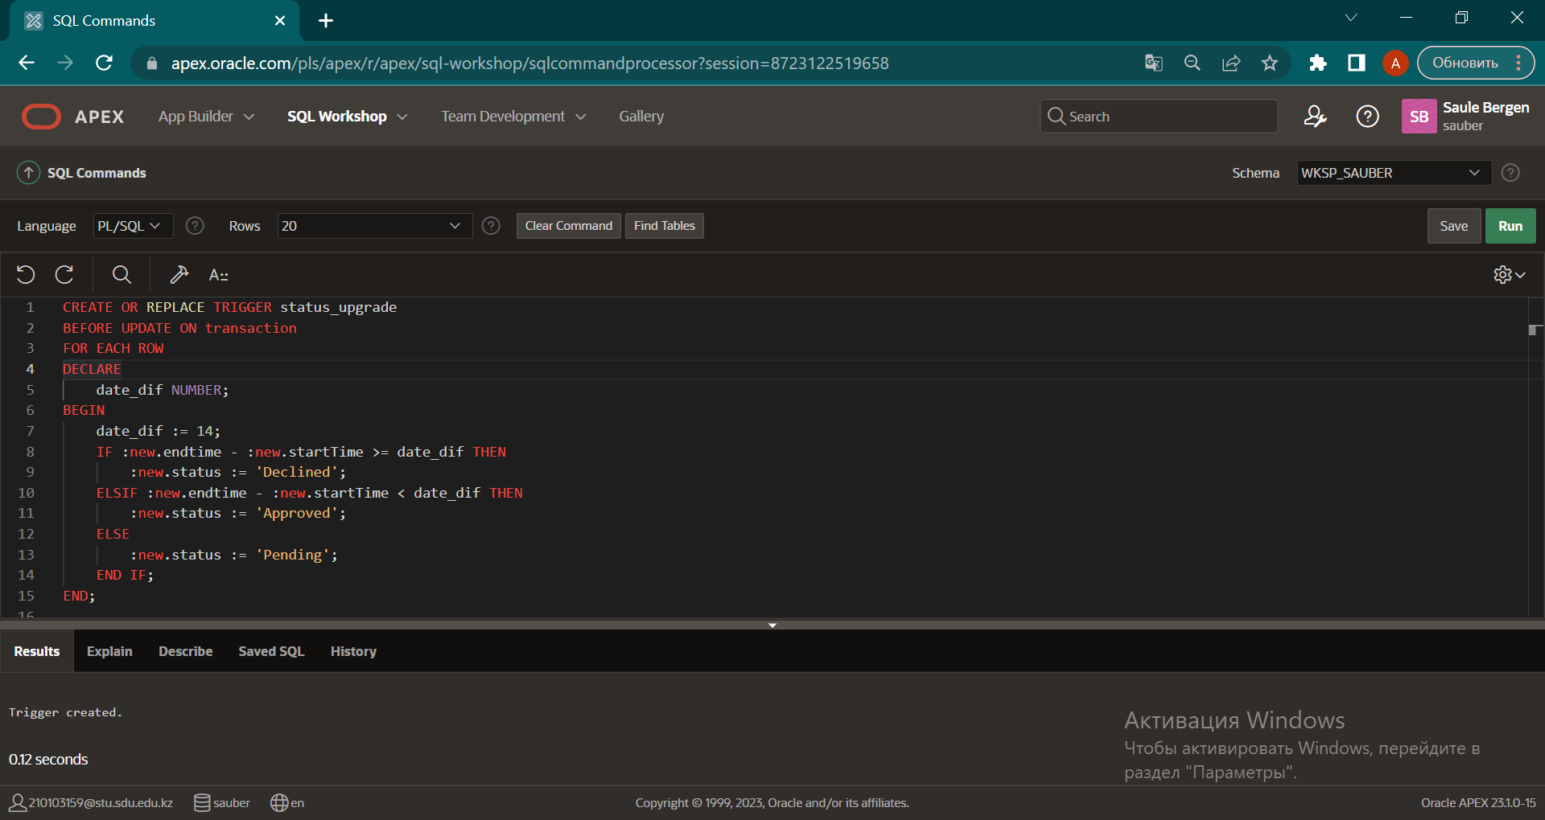

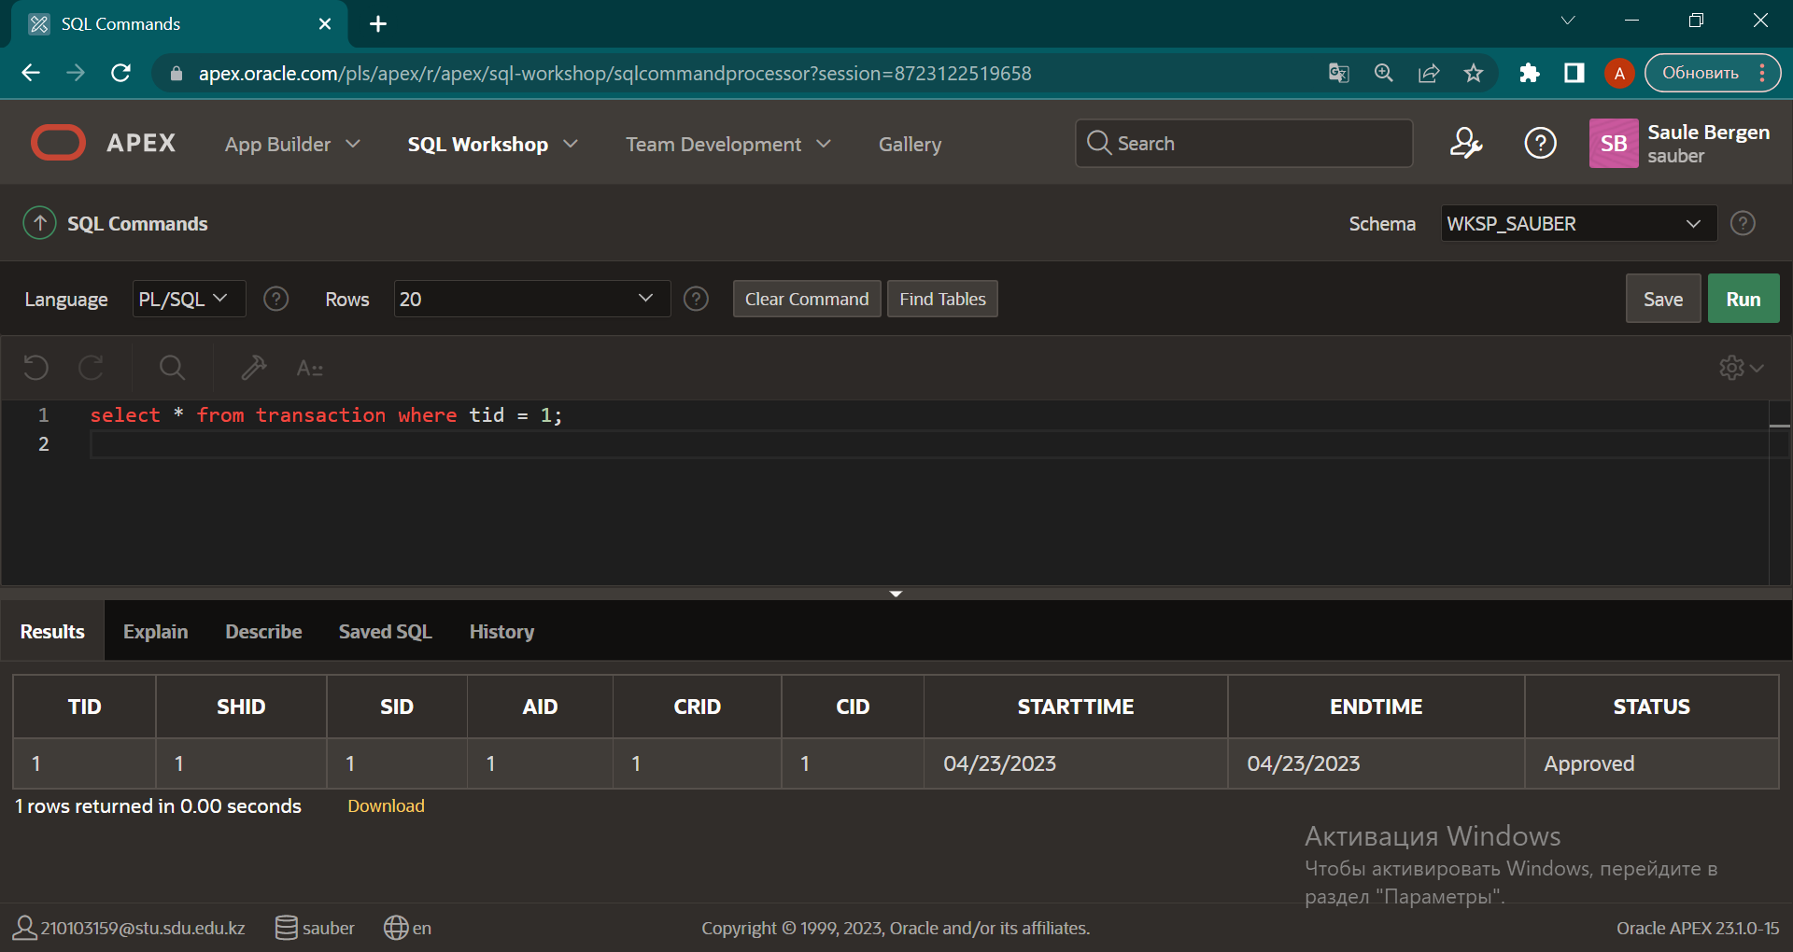

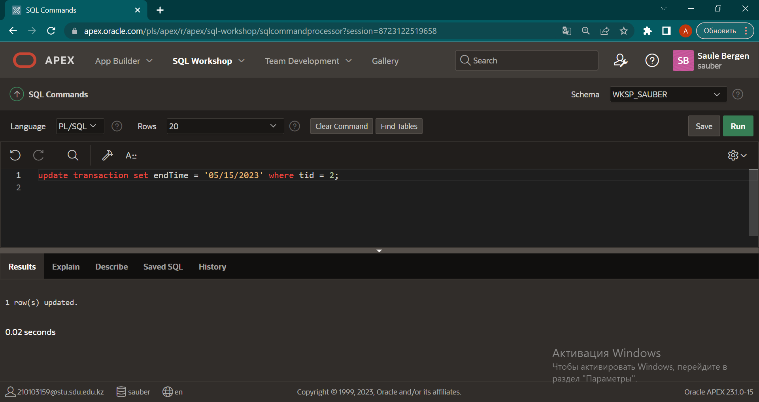

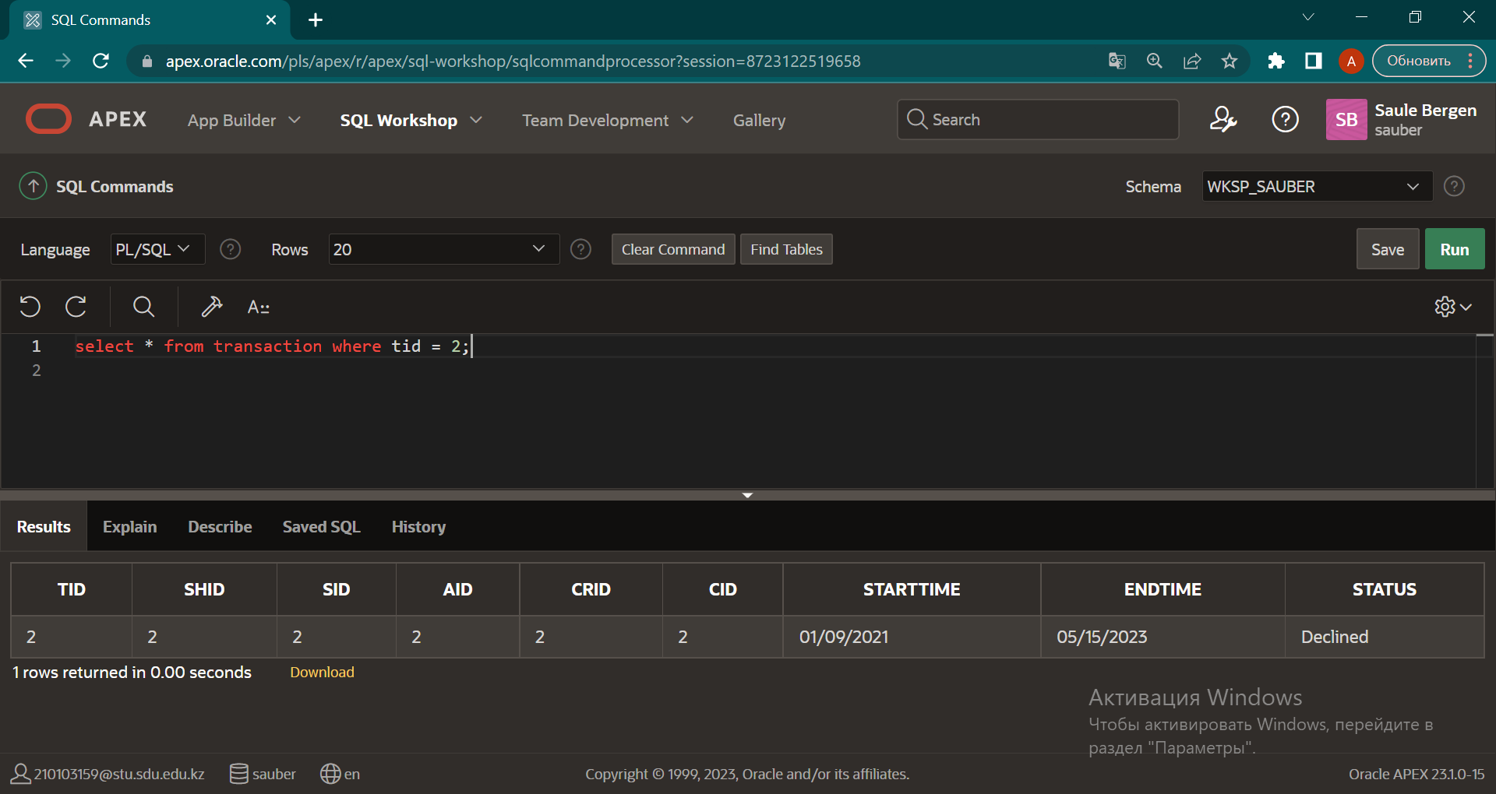

(\*) Create procedure add new user

We add new user to our db. And table add this user by their status.

If add courier status, add in table courier too.

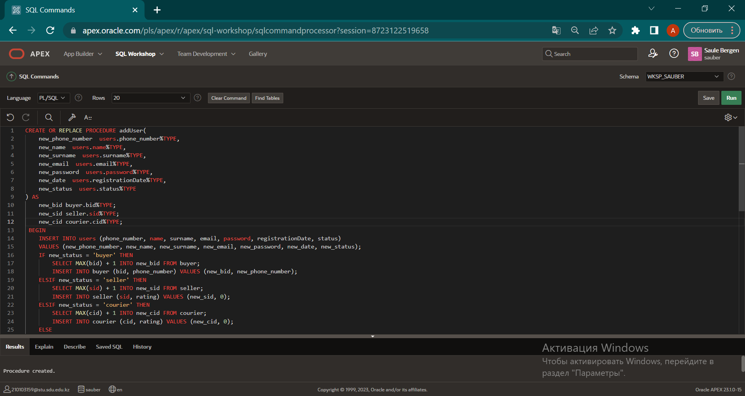

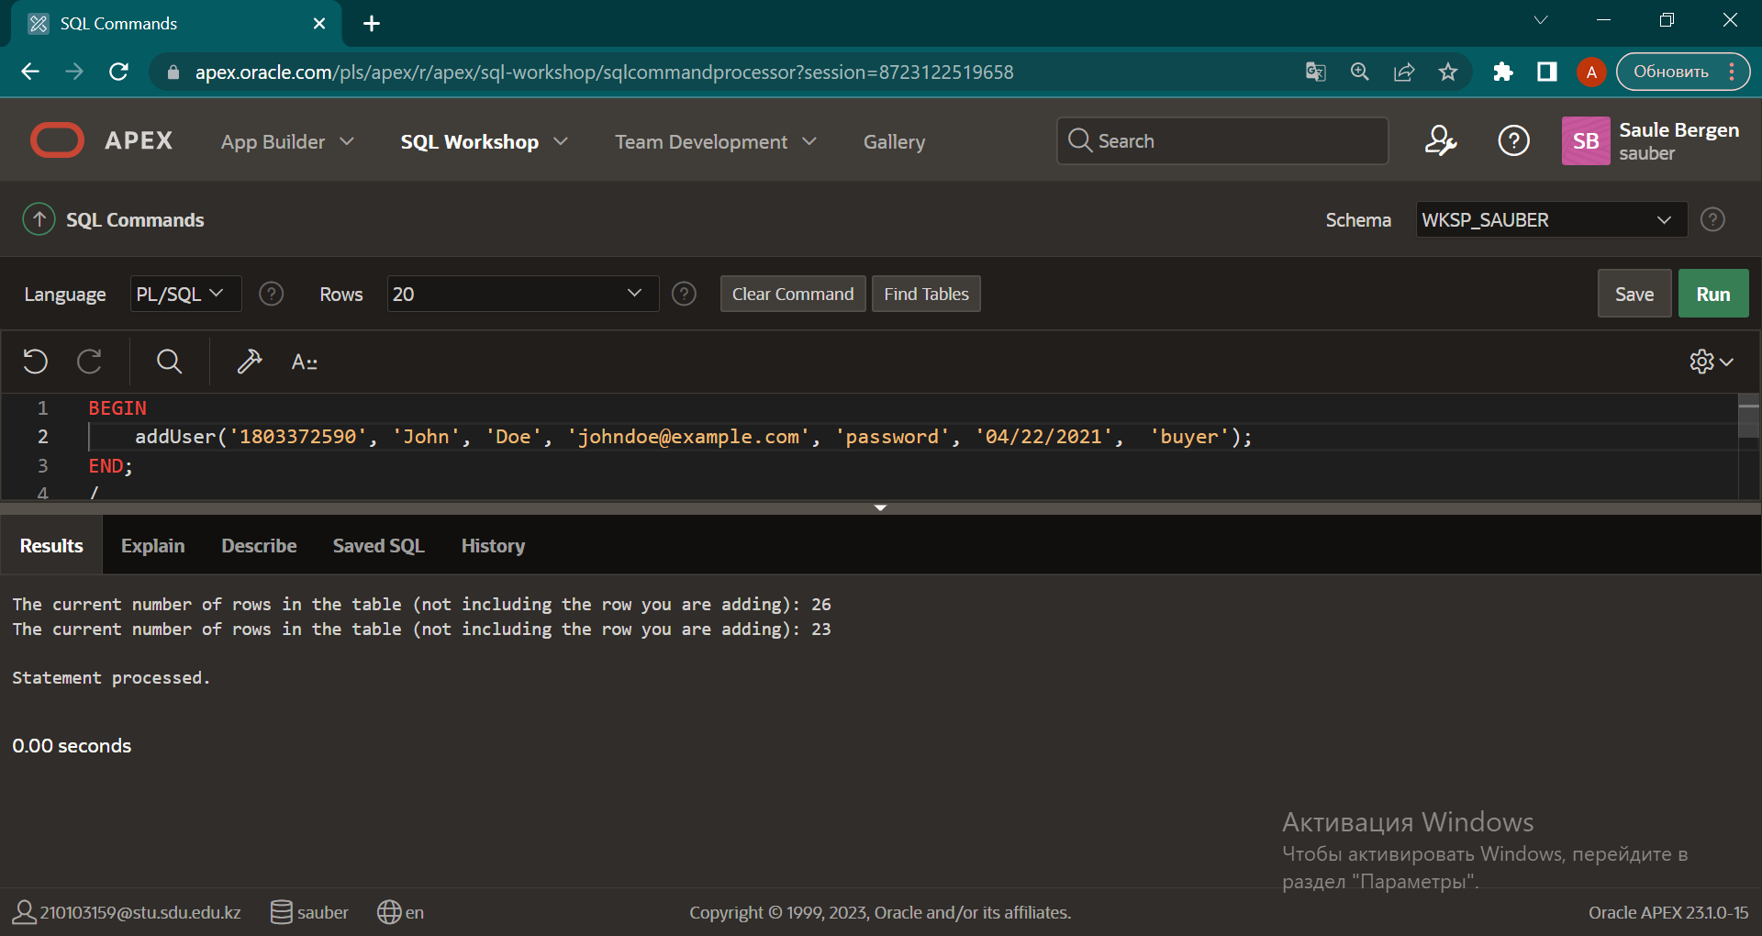

(\*) Create transaction

In particular, it selects a courier with a rating of 4 or higher that has not delivered any transactions in the last 14 days, selects the price of an item with a specific ID, updates the status and end time of a transaction with a specific ID to "Approved" and the current date, and updates card balance with a specific identifier associated with the selected courier. If the courier is unavailable or an error occurs, then throws an application error or rolls back the changes and throws an error again.

